**DAILY ONLINE ACTIVITIES SUMMARY**

|  |  |  |  |  |  |  |  |
| --- | --- | --- | --- | --- | --- | --- | --- |
| **Date:** | **22/05/2020** | | | | **Name:** | **Anusha. K** | |
| **Sem & Sec** | **4th SEM 'A' Section** | | | | **USN:** | **4AL18CS009** | |
| **Online Test Summary** | | | | | | | |
| **Subject** | | **Operating system** | | | | | |
| **Max. Marks** | | **30** | | **Score** | | **19** | |
| **Certification Course Summary** | | | | | | | |
| **Course** | **Python for machine learning** | | | | | | |
| **Certificate Provider** | | | **greatlearning academy** | **Duration** | | | **5 hours** |
| **Coding Challenges** | | | | | | | |
| **Problem statement 1:**  **Problem statement 2:** | | | | | | | |
| **Status: completed** | | | | | | | |
| **Uploaded the report in Github** | | | | **yes** | | | |
| **If yes Repository name** | | | | [**https://github.com/anusha20219/Lockdown-coding**](https://github.com/anusha20219/Lockdown-coding) | | | |
| **Uploaded the report in slack** | | | | **Yes** | | | |

ONLINE TEST DETAILS: operating system test was scheduled from 09:15 am t0 09:45am .The portion for the IA was 1st module there were questions and the time assigned was 30 minutes the questions were mcq type.



CERTIFICATION COURSE DETAILS:

This course aims at :Installation of Python

* Numpy
* Basics of Numpy array
* Broadcasting an array
* Matrix indexing
* Selection techniques
* Saving and loading arrays
* Pandas
* Series
* Indexing elements of a series
* Dictionaries
* Data frame
* Different ways of indexing in a data frame
* Conditional indexing in a data frame
* Dropna and fillna
* Groupby, merging similar to SQL logic
* Filtering, sorting and indexing
* Loops and functions
* Saving and loading a csv, excel file



**CODING CHALLENGES DETAILS**:

**Problem statement 1:**

**Write a C or Java program to implement round robin type of process scheduling.**

**Input: Process with burst time, arrival time and specify the time quantum**

**Output: Processes scheduled based on the round robin type of scheduling, with its average waiting time.**

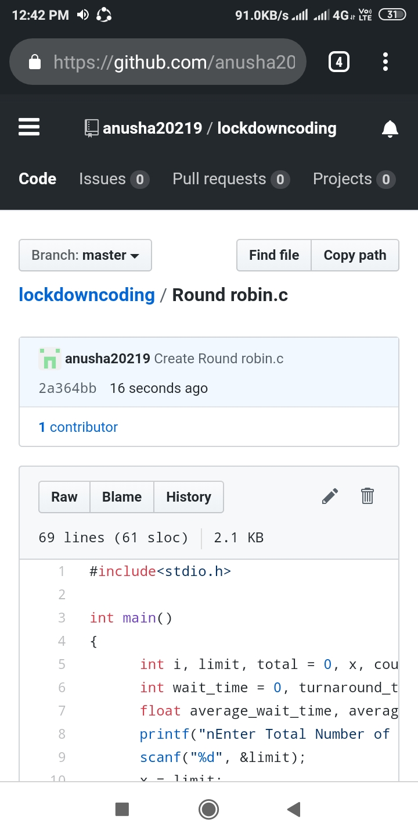

**Problem statement 2:**

**Write a C Program to implement various operations on Singly Linked List Stack.**

**Hint: First Create a Singly Linked List Stack with the node corresponding to First Element is the base of the stack; and its link field must be always Null.**

**When you push First Element, It is the First and it is Base of the stack. Its Link must be Null. Top pointer pointing to First. (top = First)**

**When you push any element, (No need of checking Stack full case because SLL is dynamic) Create a new node called temp using malloc function and insert the a number into Data field, and Link field must be pointing to top; and move the pointer top to point to temp.**

**When you pop, First check for stack Empty. If First == NULL, then Stack Empty. If it is not empty, The pointer temp must be pointing to top. Move the pointer top to top->link. Delete temp.**

**When you display the stack element, First Check for Stack Empty as in pop operation. If it is not empty, Display all the elements of current stack starting from top to First.**

